Vamsi.A
E0124067

AIM23CL301 - Reinforcement Learning Laboratory

Exp 1:
Code:
import random

class Environment:
def __init__(self):
self.state = 0
print("Environment initialized")

def reset(self):
self.state = 0
return self.state

def step(self, action):
if action == 0:
self.state = max(0, self.state - 1)
elif action == 1:
self.state = min(5, self.state + 1)
else:
pass

reward = -1
done = False

if self.state == 5:
reward = 10
done = True
elif self.state == 0 and action == 0:
reward = -5

return self.state, reward, done

class Agent:
def __init__(self):
pass

# Initialize components
env = Environment()
agent = Agent()
state = env.reset()

print(f"Initial state: {state}")

done = False
step_count = 0
episode_reward = 0

# Simulation loop
while not done:
action = random.choice([0, 1])
next_state, reward, done = env.step(action)
episode_reward += reward
step_count += 1

print(f"Step {step_count}: Action {action}, New State {next_state}, Reward {reward}, Done {done}")
state = next_state

print(f"\nEpisode finished after {step_count} steps with total reward: {episode_reward}")
Output:
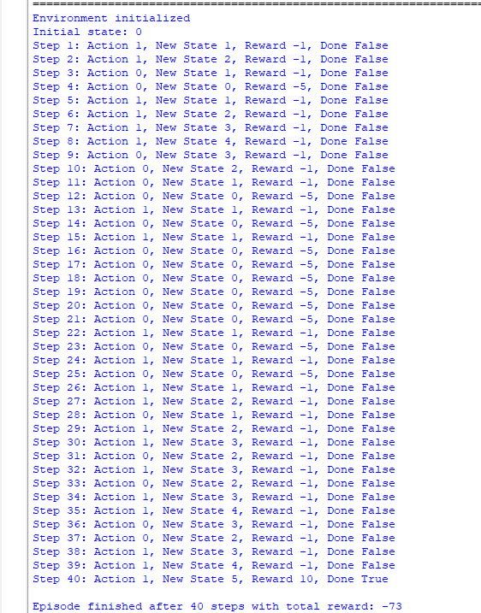

Exp 2:
Code:
import random
class Environment:
def __init__(self):
self.state = 0
print("Environment initialized")
def reset(self):
self.state = 0
return self.state
def step(self, action):
if action == 0:
self.state = max(0, self.state - 1)
elif action == 1:
self.state = min(5, self.state + 1)
else:
pass
reward = -1
done = False
if self.state == 5:
reward = 10
done = True
elif self.state == 0 and action == 0:
reward = -5
return self.state, reward, done
class Agent:
def __init__(self, action_space_size):
self.action_space_size = action_space_size
def choose_action(self, state):
# Added a basic random action selection to make the code runnable
return random.randint(0, self.action_space_size - 1)
# Main execution loop
env = Environment()
agent = Agent(action_space_size=2)
num_episodes = 5
for episode in range(num_episodes):
state = env.reset()
print(f"\n--- Episode {episode + 1} ---")
print(f"Initial state: {state}")
done = False
step_count = 0
episode_reward = 0
while not done:
action = agent.choose_action(state)
next_state, reward, done = env.step(action)
episode_reward += reward
step_count += 1
print(f"Step {step_count}: Current State {state}, Action {action}, New State {next_state}, Reward {reward:.2f}, Done {done}")
state = next_state
print(f"Episode finished after {step_count} steps with total reward: {episode_reward:.2f}")

Output:
